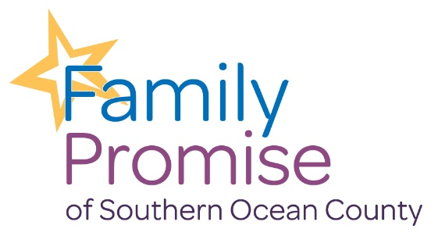

Board Member Application
Serving on the Family Promise Board of Directors can be both rewarding and challenging. The mission of Family Promise is to prevent and end homelessness for families with children, and to that end, the Board serves a vital role. The role of the board is to guide the mission, ensure financial solvency and adhere to governmental compliance. We welcome new members in the pursuit of our mission!
Date of Application Completion: Contact Information
Name: Phone:
Company: Type of Business: Current Position: Email: Address: City State Zip Do you currently volunteer with our organization: Would your company be interested in partnering in Family Promise?
Please list any nonprofit experience including current or former board service work:

How would Family Promise benefit from your involvement on the Board?

List any groups, organizations, or businesses that you could serve as a liaison to on behalf of Family Promise:

Have you received any awards or honors or completed any training or education that you would like to mention:

Skills, Experience, and Interests (Please check all that apply)
- Finance, Accounting
- Personnel, Human resources
- Administration, Management
- Nonprofit experience, Advocacy, Community Service
- Policy, Evaluation
- Fundraising, Grant Writing, Special Events, Etc.
- Public Relations, Communications
- Legal Expertise
- Real Estate
- Other:
Please send completed application to Family Promise at fpsocstaff@gmail.com

